SANNEELLA JEEVAN KUMAR
Hyderabad, Ibrahimpatnam · 9154882123 sanneellajeevan@gmail.com

Secure a responsible career opportunity to fully utilize my training and skills, while making a significant contribution to success of company.

ED UCA TIO N

COURSE | SCHOOL/COLLEGE | YEAR OF PASSING | CGPA
SCHOOLING | VIGNAN INTEGRATED HIGH SCHOOL | 2015 | 8.7
INTERMEDIATE | SRI GAYATRI JUNIOR COLLEGE | 2017 | 8.64
ENGINEERING ( IT ) | GURUNANAK INSTITUTIONS | 2022 | 5.9

TECHNICAL SKILLS
M.S OFFICE
PROFESSIONAL EXPERIENCE:
NAME OF ORGANIZATION
CREDIT ACCESS GRAMEEN LIMITED

NOV-2024 TO TILL DATE

Designation : RO ADMIN Responsibilities :
- Branch Visits
- Repair and maintenance of all branch assets – New and Replacement
- Monthly stock supply
- New branch Set-up
- Regional Office maintenance
- Trade Licenses- new and renewals
- Audit compliance (CCTV & FAR)
- Rental agreements & payment liaisoning
- MRM meeting arrangement
- Monthly tracker
- Local purchase invoice followups


Project
CORE INTEGRA CONSULTING SERVICES PVT LTD
JULY-2023 to OCT-2024
: TCSiON
Designation : Venue Admin Manager




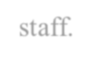

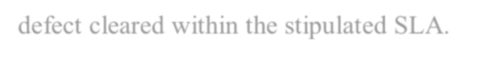
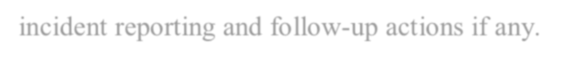
Responsibilities:
- Ensuring All invoices are raised by the Partners on time, verification, and timely submission for processing.
- strong knowledge of building management services and statutory compliance.
- Checking all Assets(IT&NON-IT)for defects with IT Managers and another dedicated staff.
- Ensuring Critical Equipment are being serviced by OEM as per schedule and regular follow-up with partner.
- oversee security, housekeeping,cafeteria managemen, stationery & Pantry .
- Ensuring all defects are recorded in the defect register and calls are logged on time and defect cleared within the stipulated SLA.
- Handling of emergencies such as earthquake, fire ,crowd menace ,medical emergencies incident reporting and follow-up actions if any.
- Ensuring all audit observations by auditers aremitigated in time.
- Liaison with partner to fulfill client specific requirement installations.
- Follow-up /liaison with OEMs for undertaking schedule servicing.
- Managing Medical Emergencies & Transport services during adverse weather.




DPS SALES & SERVICES (INDIA)
March-2022 to April-2023
Designation: Admin Executive

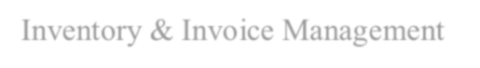
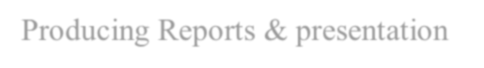
Responsibilities:
- Inventory & Invoice Management
- Producing Reports & presentation
- Managing Saftey precautions in the aspects of fire & CCTV survillance

INDIVIDUAL SKILLS & INTERSETS
- Good communication skills
- Chess player
- Vendor management
- Inventory management
- Building management
- Office management
- Calander management

PROJECT DETAILS
TITLE : Detecting Spam Messages In Twitter DESCRIPTION : This program is used to detect spam messages in twitter TECHNOLOGIES USED : PYTHON

Personal details:
Father’s name: S venkatesham Date of birth :10/7/1998 Nationality: Indian
Languages : English, Hindi, Telugu

DECLARATION
I hereby declare that the information furnished above is true to the best of my knowledge.

Place:
Date:
Signature

